DriverPass System Design Document
CS 255 – Project Two
Bryan Deacy

UML Diagrams

UML Use Case Diagram
The use case diagram below captures all major actors and their interactions with the DriverPass system. Four actors are identified: Customer, Secretary, Administrator, and IT Officer. Use cases span account management, lesson scheduling, online training, and administrative functions. Include relationships show that scheduling and taking a practice test both require prior login.
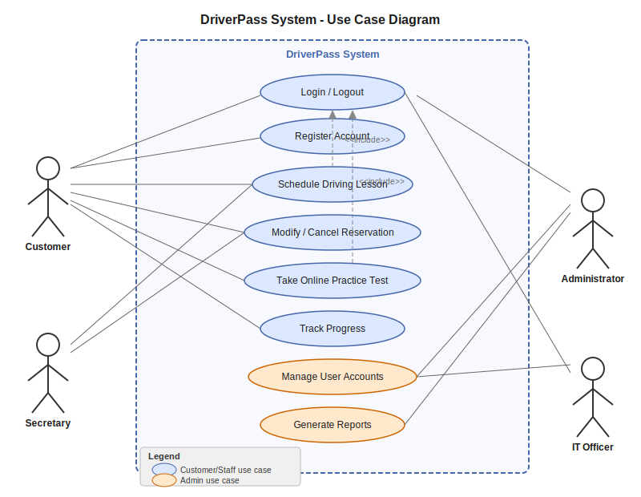
Figure 1: DriverPass System: UML Use Case Diagram
UML Activity Diagrams
Two activity diagrams were developed for this design: one for scheduling a driving lesson and one for taking an online practice test. These use cases were selected because they represent the two primary value-delivering workflows for customers.

Activity Diagram 1: Schedule a Driving Lesson
This diagram models the complete flow a customer follows to book a driving lesson. A decision node checks slot availability, routing to alternative suggestions if unavailable. Upon a successful booking, the system automatically assigns a driver and vehicle, stores the record, and sends a confirmation.
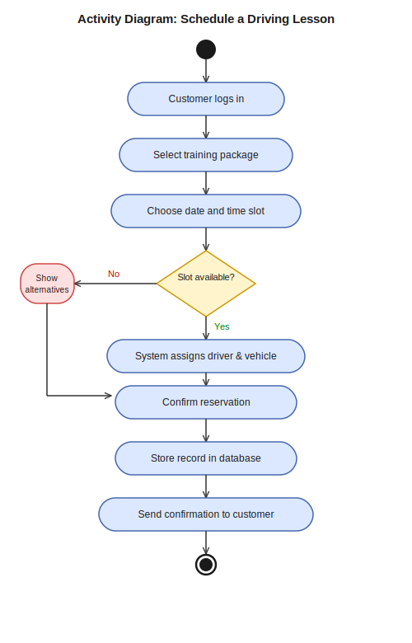
Figure 2: Activity Diagram: Schedule a Driving Lesson

Activity Diagram 2: Take an Online Practice Test
This diagram models the workflow for completing an online practice test. A looping decision node keeps the customer in the test until all questions are answered. Upon submission, the system calculates the score, saves progress to the database, and displays the results to the customer.
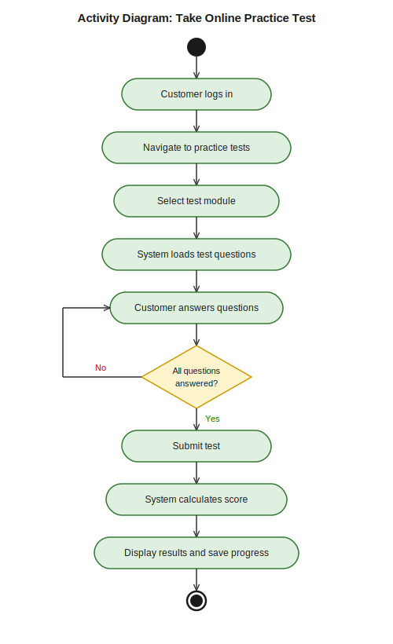
Figure 3: Activity Diagram: Take an Online Practice Test

UML Sequence Diagram
The sequence diagram below illustrates the message interactions between five system participants for the Schedule a Driving Lesson use case: the Customer, the Web Interface, the Reservation System, the Database, and the Notification Service. Solid arrows represent requests; dashed arrows represent responses. The diagram captures the full lifecycle from the customer submitting a schedule request through confirmation delivery.
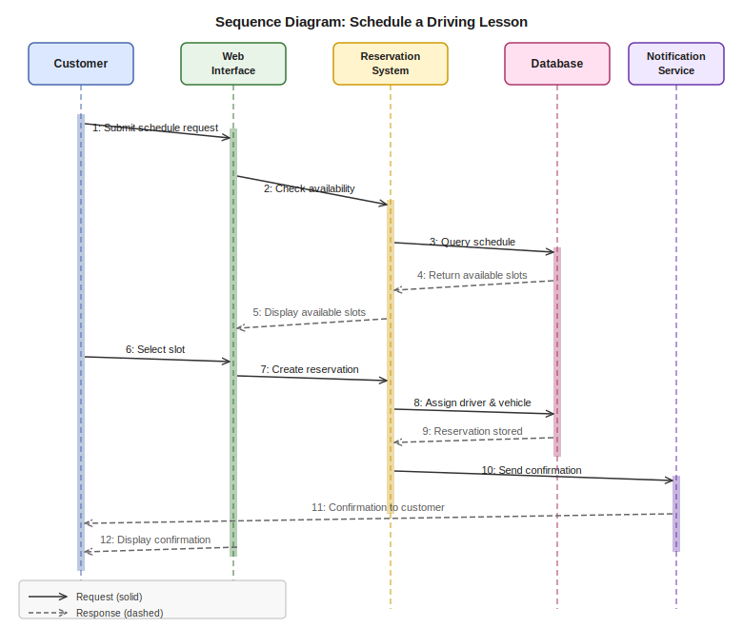
Figure 4: Sequence Diagram: Schedule a Driving Lesson

UML Class Diagram
The class diagram defines the structural blueprint of the DriverPass system. The User class acts as the parent class, with Customer and Administrator as subclasses via inheritance. Key associated classes include Reservation, Package, Driver, and Vehicle. Multiplicity annotations indicate that one Customer can hold multiple Reservations, each of which is assigned to one Driver and one Vehicle.
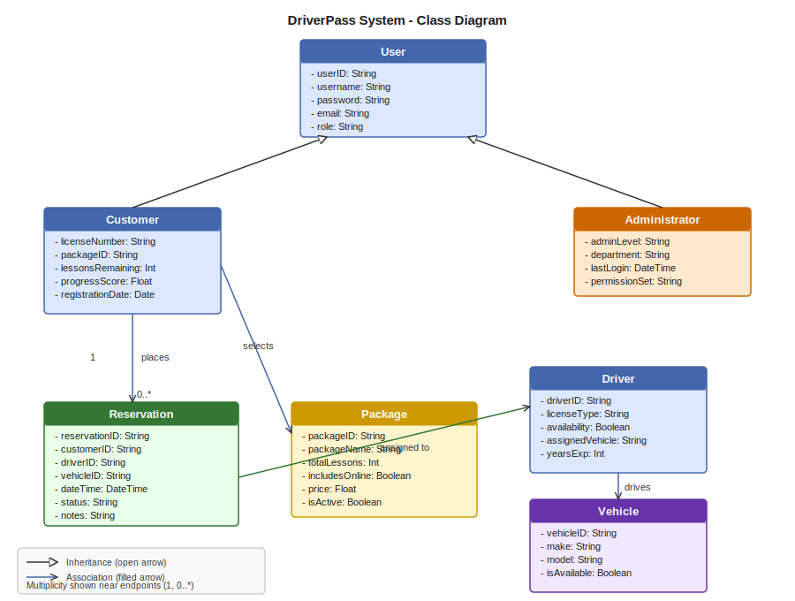
Figure 5: DriverPass System: UML Class Diagram

Technical Requirements

Hardware Requirements
The following hardware components are required to support the DriverPass system:
- Web/Application Server: A cloud-hosted server (e.g., AWS EC2, Azure Virtual Machine) capable of handling concurrent users. Minimum recommended: 4-core CPU, 16 GB RAM, scalable with load.
- Database Server: A dedicated database server instance with SSD storage, supporting at least 500 GB of initial capacity for user data, reservations, progress records, and activity logs.
- Network Infrastructure: High-availability internet connectivity with redundant connections. Load balancers to distribute traffic across server instances.
- Client Devices: Any modern device (desktop, laptop, tablet, or smartphone) owned by the end user. No specialized hardware is required on the client side.
- Backup Storage: Cloud-based or off-site backup systems to ensure data recovery in the event of failure.

Software Requirements
The system requires the following software to be installed and configured:
- Operating System: Linux (Ubuntu 22.04 LTS recommended) for all server instances due to stability, security, and cost.
- Web Application Framework: A server-side framework such as Node.js with Express, or Python with Django/Flask, to handle API requests and business logic.
- Database Management System (DBMS): A relational database such as PostgreSQL or MySQL to store structured data including users, reservations, packages, and progress records.
- Web Browser (Client): Any modern browser including Google Chrome, Mozilla Firefox, Microsoft Edge, or Apple Safari. No plug-ins or special software required on the client side.
- Authentication Library: A secure OAuth 2.0 or JWT-based authentication library for managing user sessions and role-based access control.
- SSL/TLS Certificate: An active SSL/TLS certificate to encrypt all data transmitted between client and server (HTTPS).
- Email/Notification Service: An SMTP-compatible service (e.g., SendGrid, AWS SES) for sending automated confirmation and notification emails.

Tools and Development Infrastructure
The following tools and development resources are needed to build, deploy, and maintain the system:
- Version Control: Git with a repository hosted on GitHub or GitLab for source code management and collaborative development.
- Design Tools: Lucidchart for creating and maintaining UML diagrams throughout the SDLC.
- Testing Framework: Automated unit and integration testing tools (e.g., Jest for JavaScript, PyTest for Python) to validate all functional requirements before deployment.
- CI/CD Pipeline: Continuous integration and deployment tools (e.g., GitHub Actions, Jenkins) to automate testing and release processes.
- Monitoring: Server monitoring tools (e.g., AWS CloudWatch, Datadog) to track uptime, response times, and error rates.

Cloud and Infrastructure Requirements
The DriverPass system shall be hosted on a cloud-based infrastructure to ensure scalability, availability, and disaster recovery:
- Cloud Provider: AWS, Microsoft Azure, or Google Cloud Platform (GCP) for hosting all server, database, and storage components.
- Auto-Scaling: Cloud auto-scaling groups configured to increase server capacity during peak usage and reduce it during low usage, controlling cost.
- Content Delivery Network (CDN): A CDN (e.g., AWS CloudFront) to accelerate content delivery for users across different geographic regions.
- Backup and Recovery: Automated daily database backups with a minimum 30-day retention period. A documented disaster recovery plan with a Recovery Time Objective (RTO) of less than 4 hours.
- DMV Integration: A secure API connection to external DMV systems to automatically receive and apply updates to test content and driving rules.

Security Requirements
The following technical security measures shall be implemented to protect the system and its users:
- Data Encryption: All sensitive data (passwords, personal information, payment data) shall be encrypted at rest using AES-256 and in transit using TLS 1.2 or higher.
- Authentication: Passwords shall be hashed using bcrypt or Argon2 before storage. Multi-factor authentication (MFA) shall be available for administrative accounts.
- Account Lockout Policy: User accounts shall be locked after five consecutive failed login attempts. Accounts can be unlocked by IT staff or via secure email reset.
- Role-Based Access Control (RBAC): System access shall be restricted by user role (Customer, Secretary, Driver, IT Officer, Administrator), ensuring users can only access features appropriate to their role.
- Audit Logging: All system changes, login events, reservation modifications, and administrative actions shall be logged with timestamps and user identifiers for accountability.

